QuerySquad Procurement VRD

Sales and Marketing Funnel Optimization Tool



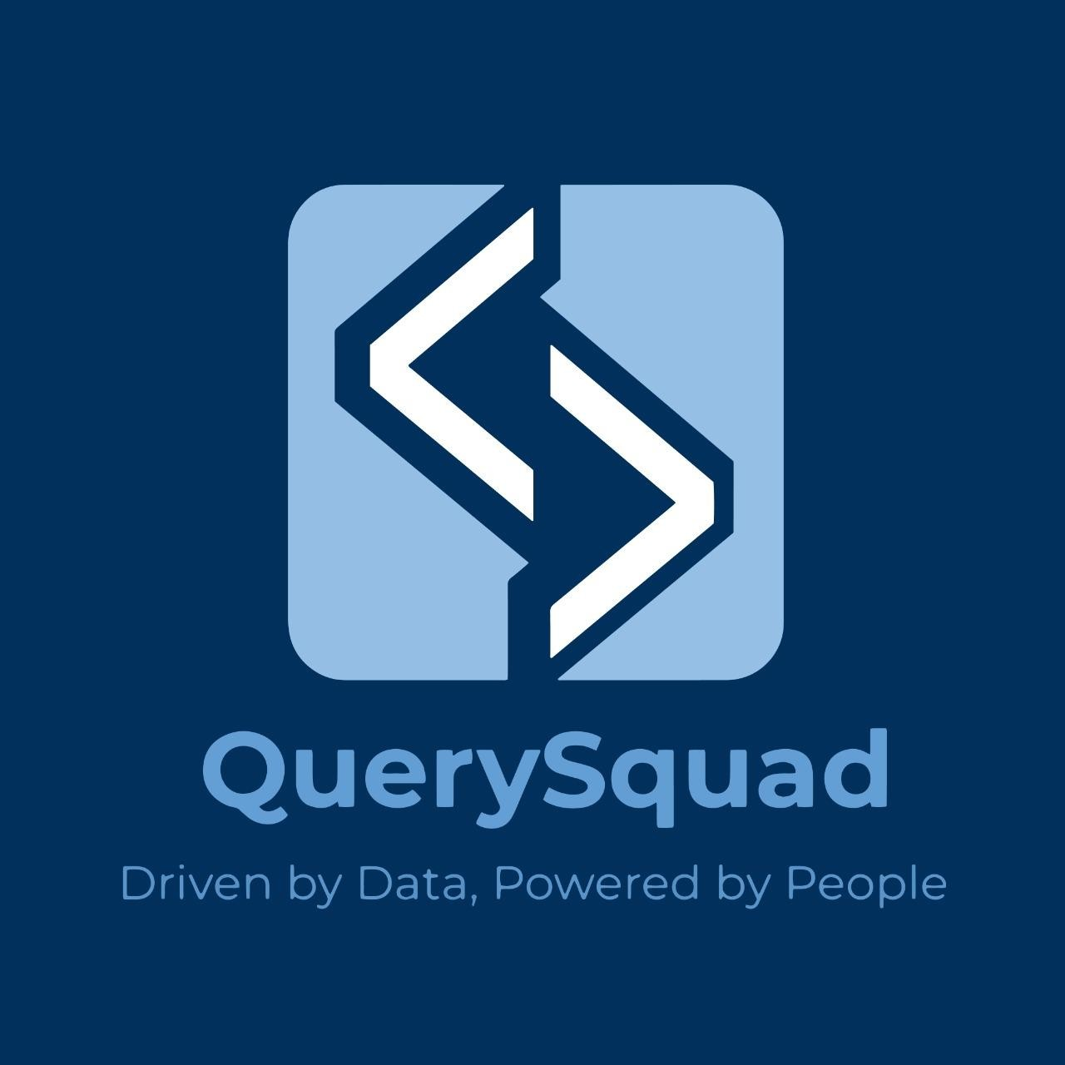
Project Name: Sales and Marketing Funnel Optimization Tool

VRD Version 1.0 23-July-2025

ERD :
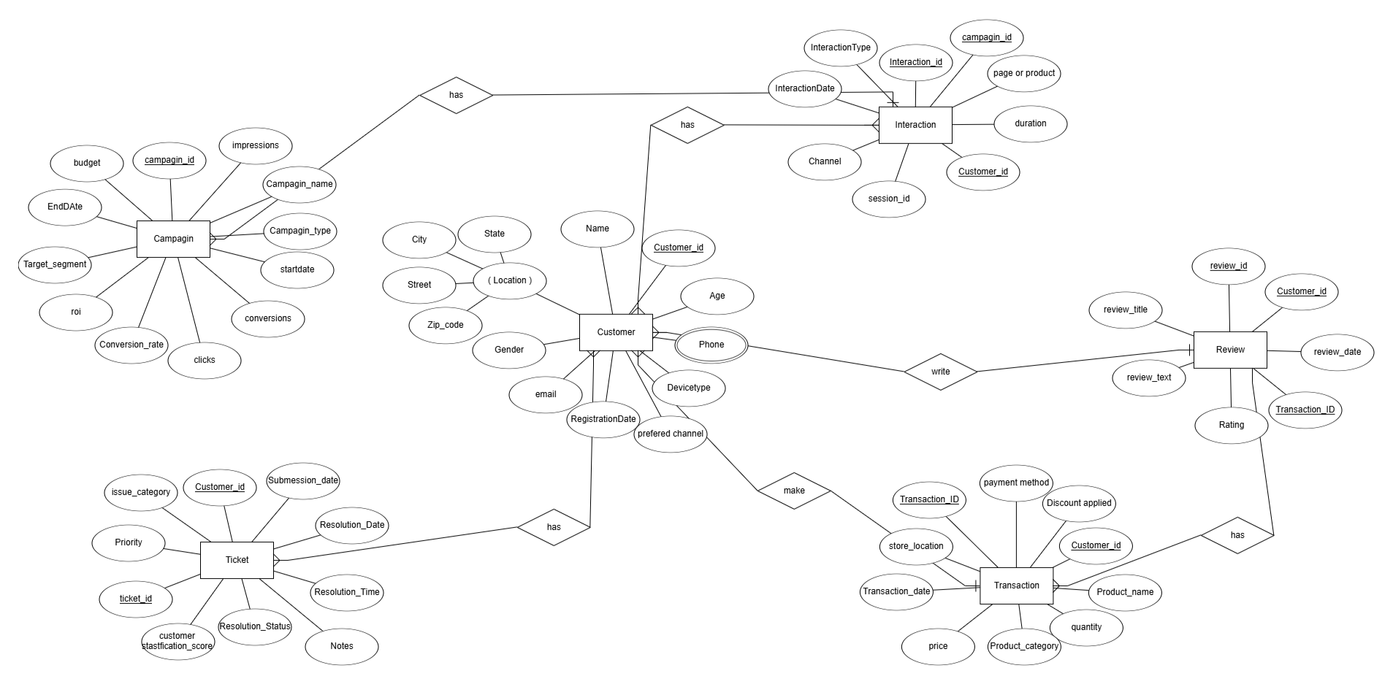

Statement of Confidentiality
The information contained in this document and related artifacts constitute confidential information of QUERYSQUAD and are intended for internal usage purposes only.

Document Control
Authors:
Date | Authors | Organization | Version | Change Description
23-07-2025 | Hussein Hamdy | QUERYSQUAD | 0.1 | Draft Version.  Document for business review.
23-07-2025 | SEIF MOHAMED | QUERYSQUAD | 0.1 | REVIEW 1
23-07-2025 | FARAH BALBAA | QUERYSQUAD | 0.1 | REVIEW 2
23-07-2025 | AHMED HOSSAM | QUERYSQUAD | 0.1 | FINAL REVIEW

TEAM MEMBERS :

ID | MEMBER | Organization | ROLE
1 | AHMED HOSSAM | QUERYSQUAD | TEAM MENTOR
2 | AHMED EHAB | QUERYSQUAD | BUISNESS ANALYST
3 | REWAN SABRY | QUERYSQUAD | DATA MODELER
4 | YASMEEN ABDALLAH | QUERYSQUAD | DATA ENGINEER
5 | YASSIN MOHAMED | QUERYSQUAD | DATA ENGINEER
6 | TOKA MOHAMED | QUERYSQUAD | DATA ENGINEER
7 | FARAH BALBAA | QUERYSQUAD | SEMANTIC CPOWER BI
8 | SEIF MOHAMED | QUERYSQUAD | SEMANTIC CPOWER BI
9 | HUSSEIN HAMDY | QUERYSQUAD | SEMANTIC CPOWER BI

VRD Summary
Understanding high-level business process requirements gathered from Inspection system to help
the departments in analyzing & monitoring various insights.
VRD Name | QUERYSQUAD - Procurement-VRD-v1.0
Requested on | 23-July-24
Business Priority | ☒ High ☐ Medium ☐ Low

Dashboard Overview
- To enable decision makers to monitor customer journey stages for a given time .
- Improved segmentation based on behavior, value, and region.
- Real-time KPI monitoring to reduce reporting delays.
- Supports data-driven decision-making across teams.

Target Audience

QUERYSQUAD
Power User | The business user who presented the business requirements for this dashboard and will provide feedback throughout the process
End users | Group/ individual users

Data Update Frequency | Daily/Weekly/Monthly

4.Dashboards (Light Theme)

Sales Dashboard
- Business Requirement No: (SCMPROC0003)
Report Name: Sales dashboard Analysis

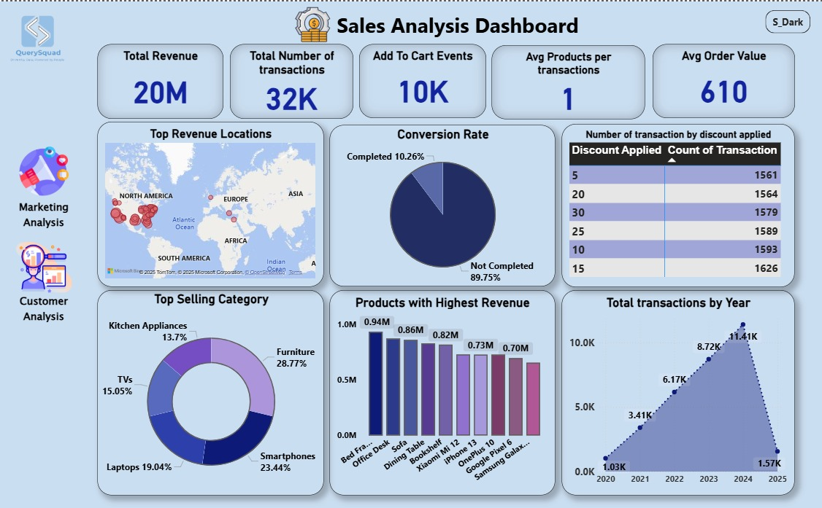

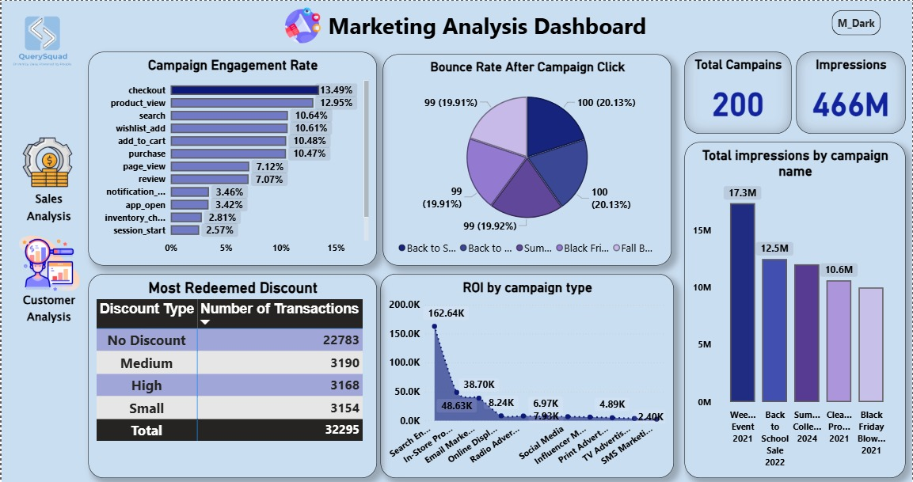

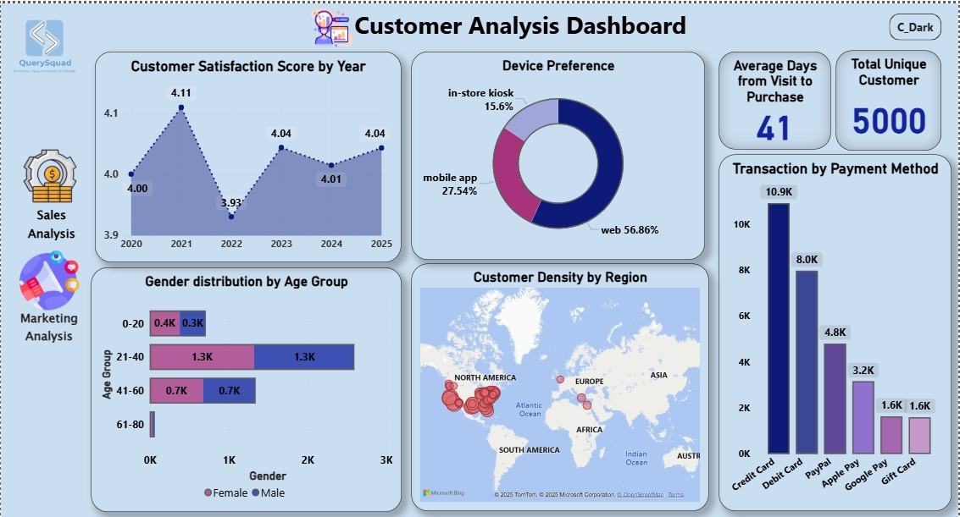

(Dark Theme)


